Statement of the problem:
Most of the students do not attend class regularly and they miss to know about their class-test or any quiz-test at most of the times. And often they do not check update of his class/examinations from their university’s website, they collects the information from their classmates. Here is a chance to get wrong information. So, the possible problems are given below:

- Students can’t attend the Class Test & Quiz Test.
- Students can’t take the preparation of Class Test & Quiz Test.
- Students can’t submit the Assignment in time.
- Students miss the class as they do not know the Class Schedule.

Introduction:
Section Notice Board is a management information system for education establishments to manage class and examinations related data. It provide capabilities for knowing class schedule, examinations schedule, assignment related information, to contact with course teachers etc. By developing this project, students can easily know about class and examinations information also can know the assignment submission date and its topic. We can summarize this in some point, they are:
- Students got Class Test & Quiz Test Schedule.
- Students can submit the Assignment in time.
- Students know the able to Class Schedule.

Strategic context:
The System Development Life Cycle

The system development life cycle (SDLC) is a conceptual model used in project management to describe the phases involved in an information system development project.

Importance of the SDLC:
The SDLC was designed to control the development environment to help ensure that developers produce a high-quality system that meets or exceeds customer expectations. The SDLC helps ensure that

- The project is completed within time and cost estimates.
- The product works effectively within the designed infrastructure.
- The product is inexpensive to maintain and is cost effective.

- Identifying problems, opportunities , and objective:
In this first phase of the systems development life cycle, the analyst is concerned with correctly identifying problems, opportunities, and objectives. This stage is critical to the success of the rest of the project, because no one wants to waste subsequent time addressing the wrong problem. The first phase requires that the analyst look honestly at what is occurring in a business. Then, together with other organizational members, the analyst pinpoints problems. Identifying objectives is also an important component of the first phase. The people involved in the first phase are the users, analysts, and systems managers coordinating the project. The output of this phase is a feasibility report containing a problem definition and summarizing the objectives. Management must then make a decision on whether to proceed with the proposed project. If the user group does not have sufficient funds in its budget or wishes to tackle unrelated problems, or if the problems do not require a computer system, a different solution may be recommended, and the systems project does not proceed any further.

- Determining human information requirements:
The next phase the analyst enters is that of determining the human needs of the users involved, using a variety of tools to understand how users interact in the work context with their current information systems. The analyst will use interactive methods such as interviewing, sampling and investigating hard data, and questionnaires, along with unobtrusive methods, such as observing decision makers’ behavior and their office environments, and all-encompassing methods, such as prototyping. The analyst will use these methods to pose and answer many questions. In the information requirements phase of the SDLC, the analyst is striving to understand what information users need to perform their jobs. At this point the analyst is examining how to make the system useful to the people involved. How can the system better support individual tasks that need doing? What new tasks are enabled by the new system that users were unable to do without it? The analyst must then ask why the business uses the current system. There may be good reasons for doing business using the current methods, and these should be considered when designing any new system.

- Analyzing system needs:
The next phase that the systems analyst undertakes involves analyzing system needs. Again, special tools and techniques help the analyst make requirement determinations. Tools such as data flow diagrams (DFD) to chart the input, processes, and output of the business’s functions, or activity diagrams or sequence diagrams to show the sequence of events, illustrate systems in a structured, graphical form. During this phase the systems analyst also analyzes the structured decisions made. Structured decisions are those for which the conditions, condition alternatives, actions, and action rules can be determined. There are three major methods for analysis of structured decisions: structured English, decision tables, and decision trees. At this point in the (SDLC), the systems analyst prepares a systems proposal that summarizes what has been found out about the users, usability, and usefulness of current systems; provides cost-benefit analyses of alternatives; and makes recommendations on what should be done.
.
- Designing the recommended system:
In the design phase of the System Development Life Cycle (SDLC), the systems analyst uses the information collected earlier to accomplish the logical design of the information system. The analyst designs procedures for users to help them accurately enter data so that data going into the information system are correct. In addition, the analyst provides for users to complete effective input to the information system by using techniques of good form and Web page or screen design. Users benefit from a well-organized database that is logical to them and corresponds to the way they view their work. In this phase the analyst also works with users to design output that meets their information needs. Finally, the analyst must design controls and backup procedures to protect the system and the data, and to produce program specification packets for programmers. Each packet should contain input and output layouts, file specifications, and processing details; it may also include decision trees or tables, data flow diagrams, and the names and functions of any pre-written code.

- Developing and documenting software:
In the fifth phase of the SDLC, the analyst works with programmers to develop any original software that is needed. During this phase the analyst works with users to develop effective documentation for software, including procedure manuals, online help, and Web sites featuring Frequently Asked Questions (FAQs), on Read Me files shipped with new software. Because users are involved from the beginning, phase documentation should address the questions they have raised and solved jointly with the analyst. Documentation tells users how to use software and what to do if software problems occur. Programmers have a key role in this phase because they design, code, and remove syntactical errors from computer programs. To ensure quality, a programmer may conduct either a design or a code walk-through, explaining complex portions of the program to a team of other programmers.

- Testing and maintaining the system:
Before the information system can be used, it must be tested. It is much less costly to catch problems before the system is signed over to users. Some of the testing is completed by programmers alone, some of it by systems analysts in conjunction with programmers. A series of tests to pinpoint problems is run first with sample data and eventually with actual data from the current system. Often test plans are created early in the SDLC and are refined as the project progresses. Maintenance of the system and its documentation begins in this phase and is carried out routinely throughout the life of the information system. Much of the programmer’s routine work consists of maintenance, and businesses spend a great deal of money on maintenance. Some maintenance, such as program updates, can be done automatically via a vendor site on the Web. Many of the systematic procedures the analyst employs throughout the SDLC can help ensure that maintenance is kept to a minimum.

- Implementation and evaluating the system:
In this last phase of systems development, the analyst helps implement the information system. This phase involves training users to handle the system. Vendors do some training, but oversight of training is the responsibility of the systems analyst. In addition, the analyst needs to plan for a smooth conversion from the old system to the new one. This process includes converting files from old formats to new ones, or building a database, installing equipment, and bringing the new system into production. Evaluation is included as part of this final phase of the SDLC mostly for the sake of discussion. Actually, evaluation takes place during every phase. A key criterion that must be satisfied is whether the intended users are indeed using the system. It should be noted that systems work is often cyclical. When an analyst finishes one phase of systems development and proceeds to the next, the discovery of a problem may force the analyst to return to the previous phase and modify the work done there.

The Seven Phases of the Systems Development Life Cycle
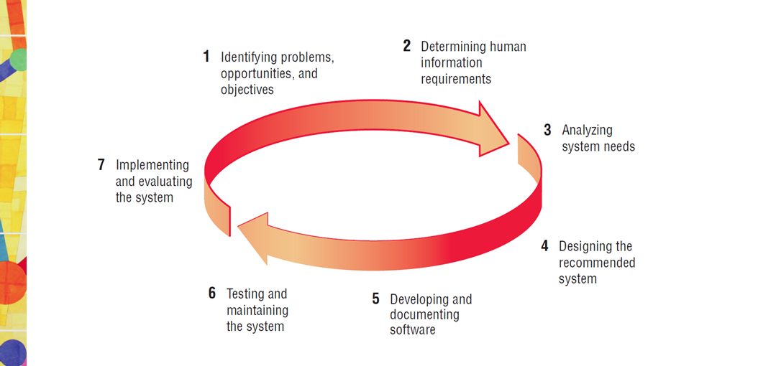

Resource:
Mainly two types of resource needed for developing the project. They are:
- Software requirements
- Hardware requirements

Software requirements | - Microsoft® Windows® 7/8/10 (32- or 64-bit)  - JDK(Java Development Kit)  - Android Studio Manager  - SDK  - Netbenas/ Eclipse
Hardware requirements | - 2 GB RAM minimum, 8 GB RAM recommended; plus 1 GB for the Android Emulator  - 2 GB of available disk space minimum,  - 4 GB Recommended (500 MB for IDE + 1.5 GB for Android SDK and emulator system image)  - 1280 x 800 minimum screen resolution

Time Factor:
Stage 1 | Analysis and Design | hours
1.1 | Requirements analysis, Mock ups creation | 12
1.2 | Work plan creation | 4
Stage 2 | Implementation
2.1 | App design creation | 40
2.2 | Database creation | 45
2.3 | General app functionality, user management | 35
2.4 | Picture upload/delete functionality | 12
2.5 | Multiple recipients’ postcards functionality | 24
2.6 | Postcards email sending functionality | 4
2.7 | Orders status back end functionality | 24
2.8 | Additional pages of content, multiple language support | 12
Stage 3 | Testing and other QA tasks | 46
3.1 | Testing and bugs fixing | 24
Stage 4 | Deployment | 6
4.1 | Deployment on uploading play store | 5

Total estimated efforts: 293 man-hour

Project Budget:
Work hours | Work rate | Total
293 | 10USD | 2930 USD

Additional Services

• Consulting services - 250 USD

Total price is 3180 USD

The total cost includes:

  - Final deliverables in accordance with project work scope listed in proposal

  - Development and testing efforts to create the entire project

  - 1 months of free bug fixing

